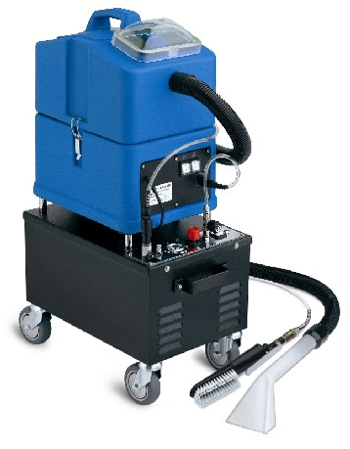
SW15 FOAM is the ideal machine for cleaning upholstery with short drying time. It sprays a special dense foam on the surface to be cleaned. After some seconds the dirt is removed by vacuuming foam with the hand tool.
Unlike a normal solution of water and detergent, dense foam does not penetrate in the depth of the textile, but acts only on the superficial layer, just where the dirt lies. This allows an excellent cleaning result and a very short drying time.
The new High Waterlift technology further improves both cleaning and drying time. The foam humidity degree is adjustable.
Main application fields: cleaning of padded seats in trains, ferries, planes, cinemas, theatres, busses and inside of cars. Also recommended for armchairs and sofas in places where a fast drying is necessary, such as for example in hotels and airports.

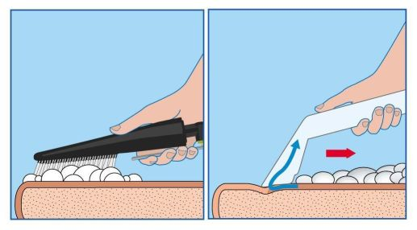



Foam Extraction System

Waterlift
Drying time
Residual dirt

SW15 FOAM

Standard
machines

HIGH
WATERLIFT
VACUUM

Advantages of SW15 FOAM:
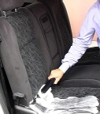
- The drying time is extremely short: seats are completely dry in about
20 minutes.

      - Cleaning the driver’s seat first, the seat is dry by the time the rest of the car is completely cleaned. The driver can therefore use his car immediately after cleaning.

      - The very short drying time allows cleaning of cars in those cases when the car owner would not accept waiting the normal drying time of injection-extraction cleaning.

      - SW15 FOAM will make it possible to perform more frequent cleaning of inside of cars.

      - Foam extraction system allows to clean many seats in a short time.

Other technical advantages of SW15 FOAM
- High density polyethylene tanks, very strong and made for lasting a long time.
- Transparent unbreakable cover, which allows to see the dirty water while it is sucked.
- Recovery tank with integrated handle. The tank can be easily detached from the machine body, in order to make the tank emptying and cleaning easier.
- The filter of the vacuum motor is easily removable for cleaning.
- The gaskets are replaceable by hand since they are not glued. Easy to clean and change.
- Strong wheels, in anti-mark rubber.
- Brass quick-disconnect couplings, reliable and strong.
- Water pump with bypass, which allows an automatic regulation of the optimal water flow according to the tool used. Moreover, the bypass device makes the pump more reliable and avoids problems in the years.
- Pump built on Santoemma specifications, for a longer life.
- Vacuum motor with thermal protection against overload.
- Vacuum motor treated against rust.
- Both motor and pump can work continuously.
- Modular design that makes the maintenance easier. The maintenance of the machine can be done at low costs.
Technical Data
Recovery tank capacity: | 4 Gal
Solution tank capacity: | 4 Gal
Tank construction: | High density polyethylene
Vacuum motor:  Power:  Maximum waterlift:  Maximum air-flow: | Two stages - High Waterlift  1500 W  100 ft  106cfm
Pump with by-pass:  Power:  Maximum pressure:  Maximum water-flow: | Vibrating  70 W  4 bar  106 cfm
Compressor: | 350 W
Max. performances: | 20-30 seats/h
Solution consumption (water + detergent): | 30-40 grams/seats
Dilution rate: | 1 part detergent to 4 parts water
Cable length: | 33 ft
Weight (machine body): | 84 lbs
Weight (packaged machine): | 121 lbs
Dimensions: | 32 x 55 x 87 cm
Package dimensions: | 42 x 65 x 100 cm
Hose length: | 8.2 ft
Standard colours: | Blue

Complete machine with hoses H10-M + foaming tool FOAM.BRUSH-M +
hand tool for vacuuming (3280) + 2 tanks of pure detergent T-FOAM

Suggested optional tools
FOAM.LANCIA-M | Foaming lance specific for places with many seats (cinemas, theatres etc.)
T-FOAM | Special foaming chemical for textiles, 1.4 Gal tank, for foam extraction cleaning
NSCARDUST | Complete tool with internal bag for vacuuming before cleaning

